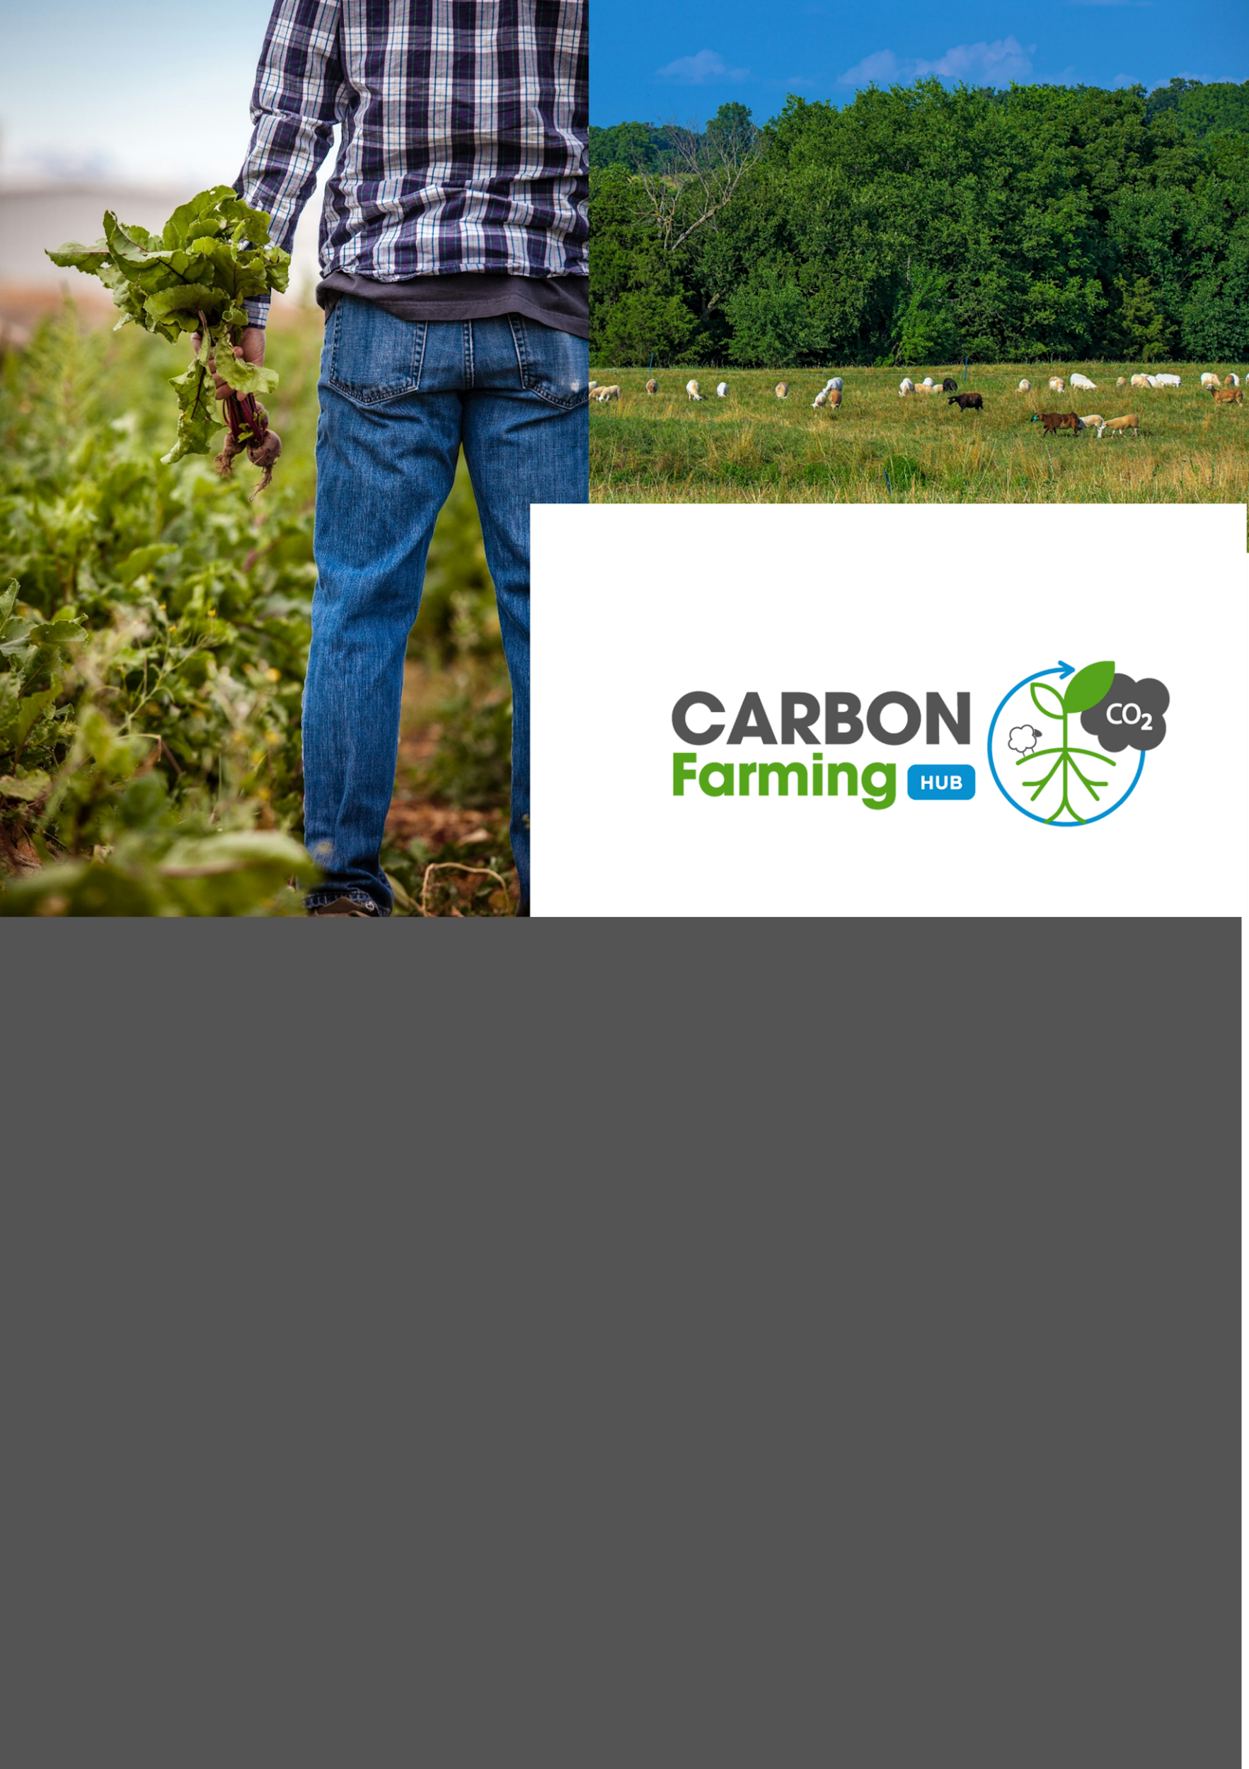

Global Framework of Initiatives – WP2

Published 11/07/2024

Written by the CarboFarmHub Consortium




This project has received funding from the European Union’s Horizon 2020 Research and Innovation Programme under Grant Agreement No 2023 1 EL02 KA220 YOU 000158211. It reflects only the author’s view and that the European Commission is not responsible for any use that may be made of the information it contains.

This document reflects the views of the author(s) and does not necessarily reflect the views or policy of the European Commission. Whilst efforts have been made to ensure the accuracy and completeness of this document, the European Commission shall not be liable for any errors or omissions, however caused.

The core study team: New Agriculture - New Generation (GR)
Theophrastus Research Institute (GR)
Academy of Entrepreneurship (GR)
CENTOFORM (IT)
Ecovalia (ES)
AGROBIO (PT)

Document information
Document history
Issue | Date | Comment | Author
V1 | 29/04/2024 | 1st draft version of the framework for partners review | AKEP
V2 | 06/06/2024 | 2nd draft version of the framework for partners review | AKEP

Glossary

Carbon Farming | Management of carbon pools, flows and GreenHouse Gas (GHG) fluxes at farm level, with the purpose of mitigating climate change.
Carbon Footprint | Total greenhouse gas emissions caused by an individual, organization, event, or product.
Cover Crops | Plants grown primarily to protect and enrich the soil, preventing erosion, increasing soil fertility, and promoting carbon sequestration.
Farm2Fork Strategy | The Farm to Fork Strategy is at the heart of the European Green Deal aiming to make food systems fair, healthy and environmentally-friendly.
Grazing | Land where farm animals feed on grass.
Rotational Grazing | A pasture management method where animals are moved between different areas to prevent overgrazing and promote vegetation regeneration, contributing to soil carbon sequestration.
Soil Carbon Sequestration | Process of capturing and storing atmospheric carbon dioxide in the soil.
Stakeholders | Individuals or groups with an interest or concern in a business or project.
Tillage | The preparation of land for growing crops.

Table of Contents
I. Document information 2
II. Glossary 3
1 Introduction 7
2 Best Practices on Carbon Farming 8
2.1 What is Carbon Farming? 8
2.2 Which techniques have the best potential? 8
2.2.1 Reduced inorganic fertilizer application & use of organic fertilizers 8
2.2.2 Reduced tillage 9
2.2.3 Improved residue management 10
2.2.4 Eliminating bare fallows & increasing the cropping of cover and companion crops 10
2.2.5 Promoting agroforestry 11
2.2.6 Turning cropland to grassland 12
2.2.7 Improved grazing land management 12
2.3 Why do farmers adopt Carbon Farming? 13
2.3.1 Farmers adoption of new practices 13
2.3.2 Farmers’ Uptake of Carbon Farming 14
2.4 How to persuade farmers to get involved in Carbon Farming? 15
2.4.1 Explain that it is something they know 15
2.4.2 Highlight the co-benefits 15
2.4.3 Use the farmers’ peer example 16
2.4.4 Communicate it effectively 16
2.4.5 Address the diversity of motivations 17
2.4.6 Use appropriate promotional material 17
2.5 Prior EU-level projects on Carbon Farming 18
2.5.1 SmartSOIL 19
2.5.2 Interreg North Sea Carbon Farming 19
2.5.3 LIFE CarbonFarmingScheme 19
2.5.4 Interreg Central Europe Carbon Farming 19
2.5.5 LIFE Carbon Farming 19
2.5.6 Carbon Farming Projects Inventory 19
2.5.7 OrganicClimateNET 20
3 Outreach Strategy 21
3.1 Objectives 21
3.2 Target Group 21
3.3 Ways to reach out 22
3.3.1 Methods & tools 22
4 Framework of Initiatives 23
4.1 Initiative 1 – Carbon Farming: Tradition meets today (proposed by: NANG) 24
4.2 Initiative 2 – Participatory Carbon Farming: Photographic competition (proposed by: NANG) 26
4.3 Initiative 3 – Questionnaires on Carbon Farming Management (proposed by: Centoform) 28
4.4 Initiative 4 – Roundtables: Q&A with professionals (proposed by: Ecovalia) 30
4.5 Initiative 5 - Webinars to educate target group on best practices (proposed by: AKEP, Agrobio) 32
4.6 Initiative 6 – MOOC course: Knowledge pills on organic farming (proposed by: Ecovalia) 34
4.7 Initiative 7 – Field visits (proposed by: Theophrastus) 35
4.8 Initiative 8 – Podcasts (proposed by: AKEP, Centoform) 36
4.9 Initiative 9 – Dissemination actions with farmers (proposed by: Agrobio) 38
4.10 Initiative 10 – Celebration of Organic Agriculture and Carbon Farming: Carbon Farming Management (proposed by: Agrobio) 39
5 Digital CarboFarmHub 40
Bibliography 41

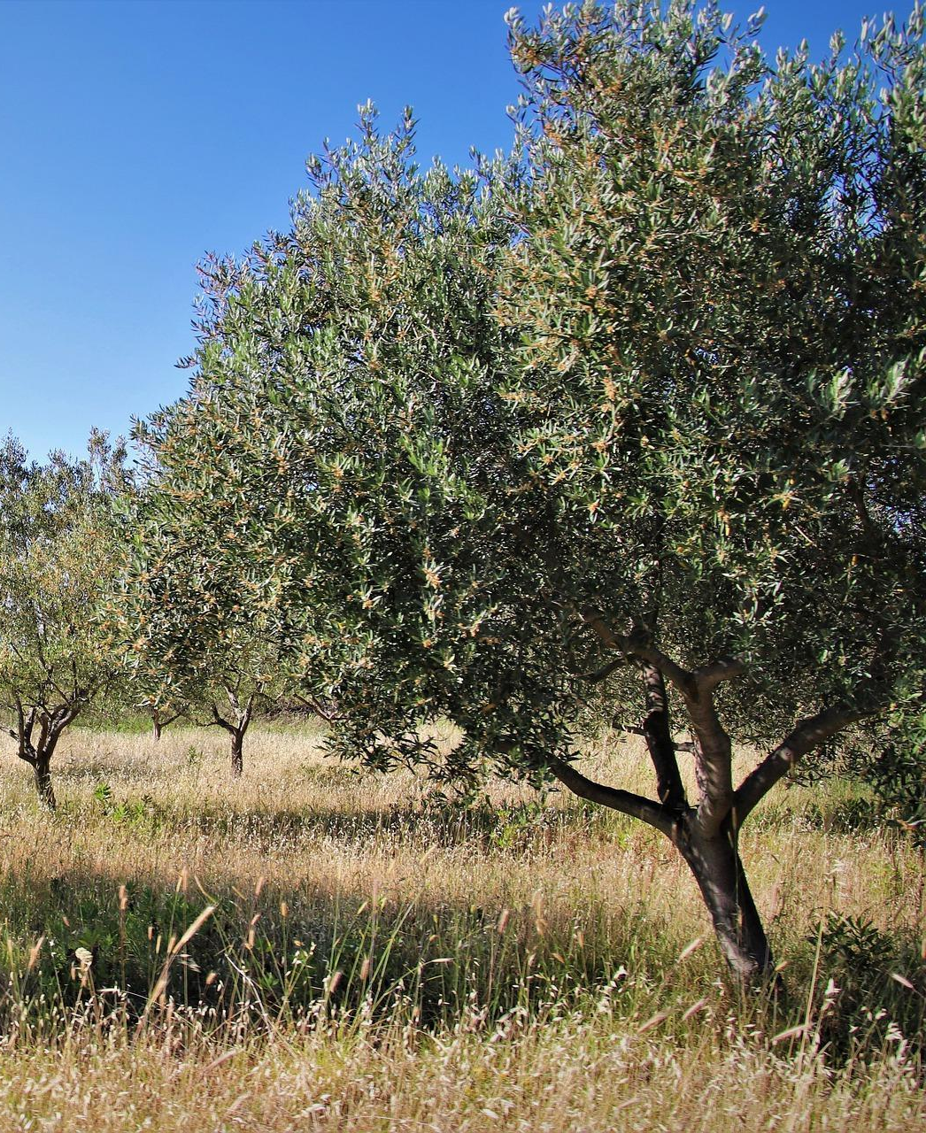

Introduction

The CarboFarmHub (full title: Carbon Farming Awareness Hub) is a project aiming to create a network of carbon farming awareness hubs located in the 4 partner countries (GR, IT, ES, PT), to answer to the common and crucial needs of increasing awareness and upskilling of young citizens and farmers to be ready to face the new challenges and exploit modern socio-economic opportunities for sustainable societies.
To achieve that, the first step is to develop a Global Framework of Initiatives, providing learning opportunities and specifically designed actions to youngsters to increase their awareness of emerging issues such as green transition as well as existing and promising opportunities. In this way, they will be able to interpret the current challenges and arising opportunities and establish a key role in the primary sector by promoting, at the same time, exchanges with policymakers and main stakeholders.
The second step is to design the CarboFarmHub virtual exchange space. This user-friendly environment will guarantee that any interested person, including people outside the partnership or located in other countries, will have the opportunity to participate in awareness-raising and training activities (e.g, workshops, webinars, virtual cafes, etc.). Online events will be live-streamed. Some of them will be delivered in English, to boost international dissemination and visibility and also in the different partners’ languages. The virtual Hub will offer, besides live-streamed events, their recording and a repository space to access a set of relevant resources such as studies, research, EU recommendations on the core topics, presentations used by keynote speakers, and, last but not least, the main deliverables of the project, etc., to support knowledge sharing and debate inside an international green community of practices.
This document is the Global Framework of Initiatives constituting the CarboFarmHub, a detailed document describing the panel of awareness-raising and outreach activities that partners will implement at the local and international level (virtually). The document comprises written text, pictures/infographics, and an overall timeline of the initiatives in coherence with the project’s implementation plan. This document will represent and refer to the piloting described in the following work package. The developed activities will be based on the area of expertise of each partner and on the co-creation activities within the partnership. Activities will be implemented in WP3 and designed to take place on 5 levels (local, regional, national, international, and global).

The project is implemented by 6 organisations based in 4 countries as part of the Erasmus+ program:

* NEW AGRICULTURE, NEW GENERATION (GR)
* Academy of Entrepreneurship (GR)
* Theophrastus Research Institute (GR)
* CENTOFORM (IT)
* Ecovalia (SP)
* AGROBIO (PT)

Best Practices on Carbon Farming

What is Carbon Farming?

According to the European Union “Carbon farming” refers to the management of carbon pools, flows and GHG fluxes at farm level, with the purpose of mitigating climate change. This involves the management of both land and livestock, all pools of carbon in soils, materials and vegetation, plus fluxes of carbon dioxide (CO2) and methane (CH4), as well as nitrous oxide (N2O)” (European Commission, n.d.).

Which techniques have the best potential?

There are many farm management ways/activities which can meet the goals of ‘carbon
farming’ (See Fig.1 for some examples).

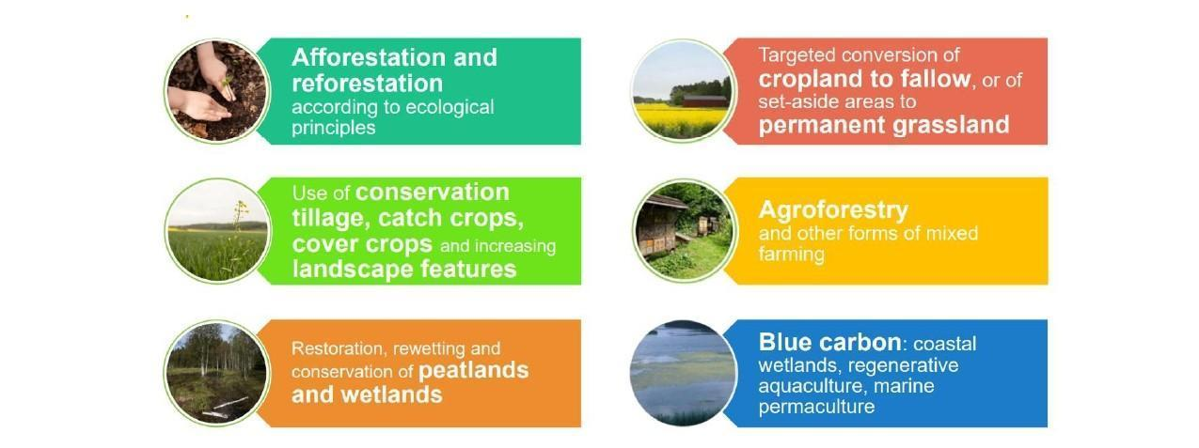

Fig 1: Examples of Carbon Farming schemes (https://ilvo.vlaanderen.be/uploads/documents/Agenda/01_Ingroductie-Discussieforum-Carbon-Farming.pdf)

Reduced inorganic fertilizer application & use of organic fertilizers

Chemical inputs reduce the capacity of soils to sequester carbon and can be wasteful when applied in excess. Hence, reducing chemical fertilizer usage is a cost-effective method to optimize nutrient application for crops and enhance soil health. Similarly, incorporating organic materials like compost and manure can boost soil carbon levels. This occurs not only because of the carbon content in these additives but also due to their positive effects on soil structure and nutrient availability, which in turn enhance plant productivity and increase carbon inputs from plant residues. A study in California found that following modest compost additions (a one-time ∼1.3 cm thick surface dressing) resulted in substantial increases in soil C storage in the two sites examined (0.5 tC/ha and 3.3 tC/ha respectively, 3 years after the compost addition). This was partly attributed to improved water infiltration and retention, enhanced grass productivity, leading to increased root and residue inputs into the soil. (Rosende, 2022)

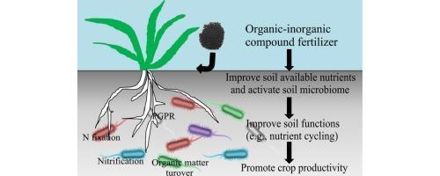

Fig 2: Organic vs. inorganic fertilizers (https://www.sciencedirect.com/science/article/abs/pii/S0929139315301220)

Reduced tillage

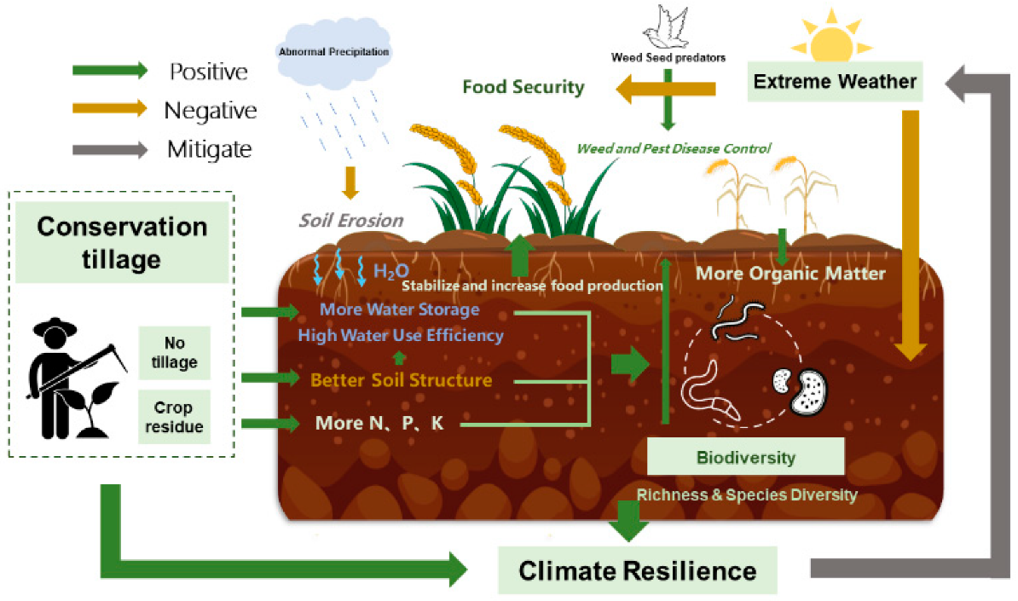

Fig 3: Reduced tillage scheme (https://www.mdpi.com/2073-4395/12/7/1575)

Farmers utilize tillage to manage crop residues and prepare soil for planting, serving as the primary method of soil disturbance in annual croplands. Excessive and frequent tilling not only leads to soil erosion, but also diminishes soil carbon levels. Additionally, tillage accelerates the breakdown of stable soil aggregates, which typically shield organic matter from decomposition, thereby increasing the release of carbon dioxide from the soil. Under reduced or no-tillage (NT) the aggregation and aggregate stability is significantly enhanced, which is believed to be the main mechanism promoting increased C storage under NT. Although numerous field studies and reviews have demonstrated increases in soil organic carbon (SOC) with reduced tillage and no-tillage approaches, variations are observed due to differences in soil texture and climate. For example, a global analysis in 2004 reported increases in dry climates of 0.1 tC/ha/y versus 0.22 tC/ha/y in humid climates. (Paustian et al., 2019)

Improved residue management

One effective method to increase soil organic carbon (SOC) is by planting high-residue crops and allowing the residue to decompose naturally in the field. The interaction between residual organic matter and microorganisms is now recognized as playing a more significant role in the formation and sequestration of carbon in the soil than previously believed. For instance, a meta-analysis of studies conducted in Chinese croplands found that leaving residue in the field led to an 11.3% increase in soil carbon storage compared to removing the residue. (Witzgall et al., 2021)

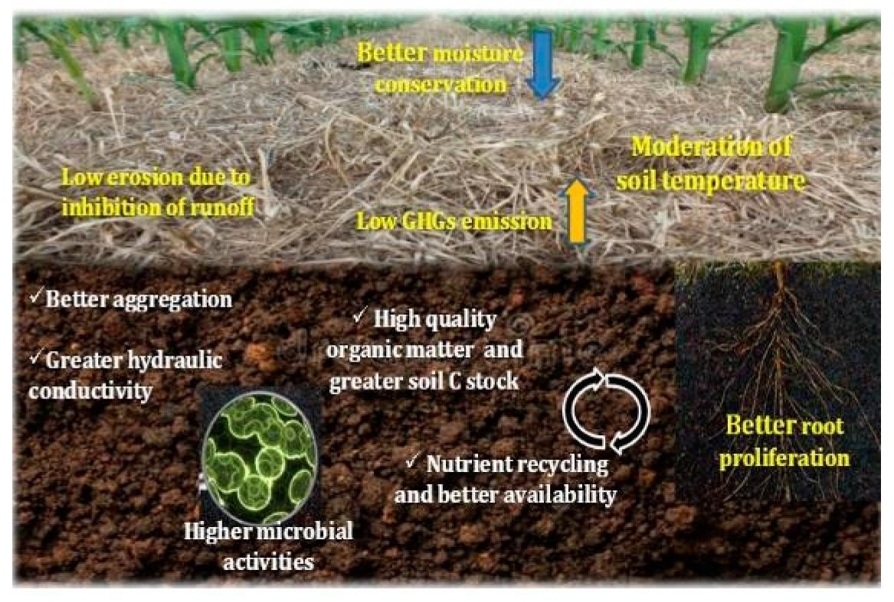
Fig 4: Improved residue management (https://www.mdpi.com/2071-1050/12/23/9808)

Eliminating bare fallows & increasing the cropping of cover and companion crops

Leaving cultivated land fallow for a season or longer exposes the soil to various elements such as heat, wind, rain, and weeds, which can lead to increased loss of soil carbon. Consequently, farmers often explore different cropping strategies to enhance carbon inputs into the soil. One of the most recommended carbon farming methods is to introduce cover cropping. These crops are specifically grown to shield the soil, differing from the main crop typically grown on the farm. Cover crops minimize surface disturbance and aid in nutrient retention, thus enhancing soil fertility and organic carbon levels. The same goal is achieved through companion planting (i.e. growing two or more crops close together). This practice does not only protect the soil, but it also increases biodiversity as well as the growth and production of crops. Examples include basil, which can protect tomatoes (the primary crop) from insect pests, while clover, as a nitrogen-fixing crop, enhances soil nitrogen levels, thereby aiding in carbon retention. A recent review of cover crops reported a mean annual sequestration rate of 0.32 tC/ha/y, with several studies reporting rates higher than 1 tC/ha/y. (Wang et al., 2020)

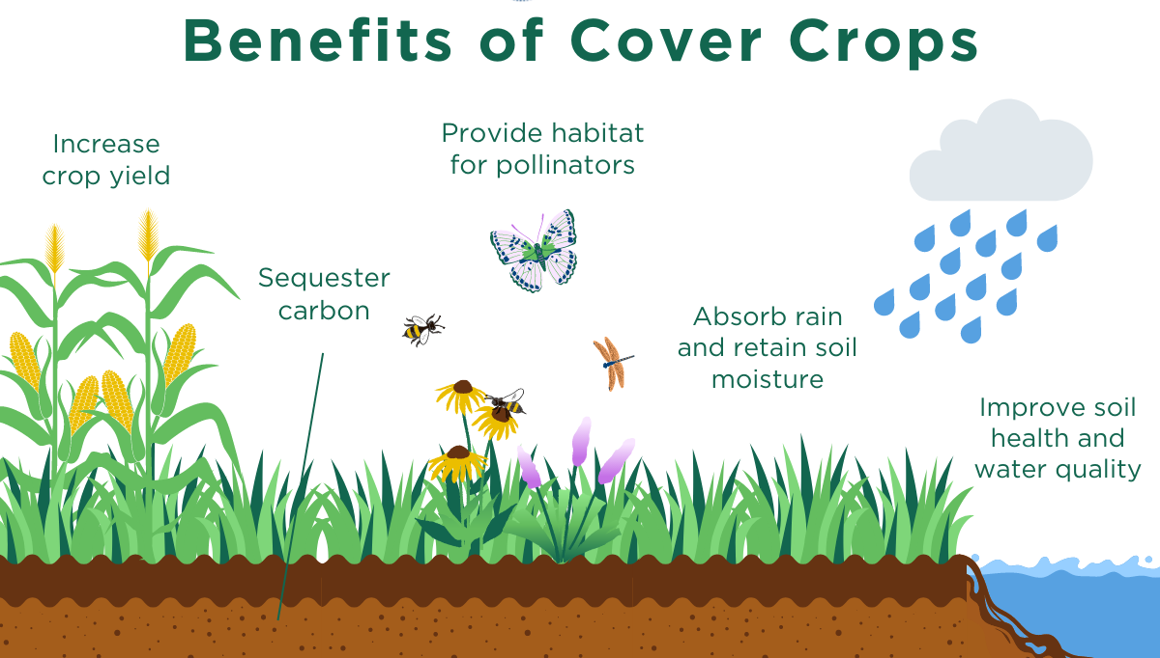

Fig 5: Cover crops (https://www.eesi.org/articles/view/cover-crops-for-climate-change-adaptation-and-mitigation)

Promoting agroforestry
Agroforestry, which involves deliberately integrating trees into agricultural practices, offers a range of benefits including enhanced farm productivity, soil protection, improved air and water quality, wildlife habitat provision, and diversified income sources. Additionally, agroforestry contributes to emissions mitigation and carbon storage in both soil and trees. A recent review of research showed that transitioning from conventional agricultural methods to agroforestry systems significantly increased carbon sequestration by 28.34%. Among various agroforestry approaches, Agri horticulture, where fruit trees are incorporated, demonstrated the highest mean soil carbon stock, with a 31.64% increase compared to conventional systems, meaning that agroforestry is a subsequent method of successfully reducing carbon emissions in the agricultural sector. (Kumara T.M. et al., 2023)
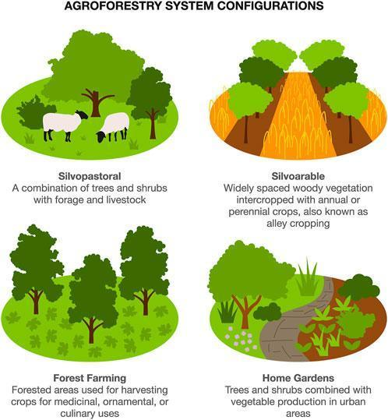

Fig 6: Agroforestry System (https://climatalk.org/2023/06/28/agroforestry-for-biodiversity-and-climate-resilience/)

Turning cropland to grassland

When croplands are transformed into perennial vegetation such as grasses or trees, we notice both an uptick in carbon inputs and a decrease in soil disruption. A synthesis of research conducted in 2016 projected a 39% rise in carbon stocks following the conversion of annual cropland to grassland, with an average accumulation rate of nearly 0.9 tC/ha/year. Moreover, these accumulations can persist for numerous decades. (Conant et al., 2017)

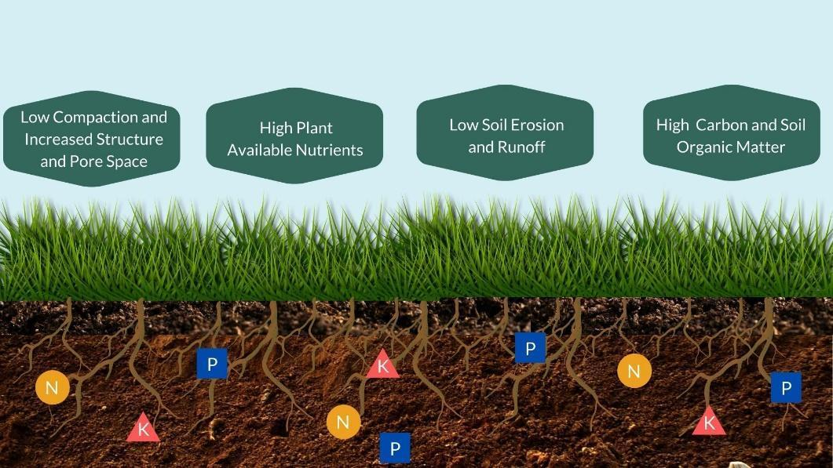

Fig 7: Cropland Conversion (https://www.tjswcd.org/cropland-conversion-2/)

Improved grazing land management

The impact of grazing on soil carbon sequestration varies greatly depending on various factors such as climate, vegetation, livestock characteristics, and grazing methods. Generally, on a global scale, light grazing, such as seasonal or rotational grazing, has minimal negative effects and may even support soil carbon storage. Conversely, moderate and heavy grazing, particularly continuous grazing, consistently diminishes soil carbon stocks. Research indicates that transitioning from continuous to rotational grazing can increase soil organic carbon stocks by nearly 30% on average, while switching from sheep to cattle can mitigate the adverse effects on soil carbon. Nevertheless, the influence of management practices on soil carbon stocks is contingent upon specific circumstances, including climate, plant community composition, and soil properties. Therefore, grazing strategies should be implemented with a comprehensive understanding of the local context. (Zhou et al., 2017) (Bai & Cotrufo, 2022)

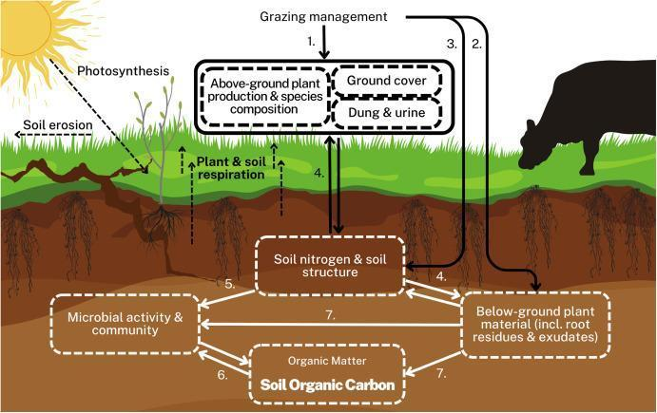

Fig 8: Grazing Management (https://www.sciencedirect.com/science/article/pii/S0301479723019345)

Why do farmers adopt Carbon Farming?

Farmers adoption of new practices

Based on current research, Kragt et al. (2017), the adoption of new farming practices depends on a complex interaction of several factors. Key drivers influencing the adoption of land management practices encompass characteristics related to: (1) the specific land management practice; (2) the farm or landholding; (3) the individual farmer or landholder; and (4) the broader context, particularly the social environment. Specifically:

(1) Characteristics of the practice
The main characteristics of new practices that encourage their adoption include: (i) their comparative superiority over existing practices, (ii) whether this superiority entails multiple benefits such as financial gains, increased productivity, and environmental advantages, and (iii) their ease of integration into the existing farming system, making them accessible for landholders to experiment with.

(2) Characteristics of the landholding
Multiple studies suggest that larger farms and higher profitability correlate positively with the adoption and engagement in new programs. Microclimate variations and natural resource availability can influence participation decisions, alongside the specific type of farm, as certain types of farms (e.g. crop-based versus livestock-based) may be better suited for different conservation practices.

(3) Characteristics of the landholder
The socio-demographic or attitudinal traits of landholders engaged with a specific practice or program can influence their decisions regarding adoption and participation. Socio-demographic factors comprise education level, income, agricultural training, years of farming experience, and the presence of children who will inherit the property. Crucial attitudinal aspects encompass a farmer's perception of their own expertise, attitudes towards the environment, conservation, and climate change, as well as their outlook on future risks and financial circumstances.

(4) Characteristics of the context
The context in which a particular practice or program is situated could be defined in different ways; social, geographical, political, temporal, etc. The literature commonly points to the importance of the social context and the critical role of social networks in the adoption and participation processes. For example, the adoption of conservation agriculture is greatly enhanced when trusted colleagues endorse the novel practice. Similarly, landholders are more likely to participate in environmental policy programs when they feel connected to other participating landholders (Rust et al., 2020).

(5) Characteristics of the program
Finally, the effectiveness of land management programs in encouraging participation and uptake is influenced by various factors related to their design and implementation. These factors include the presence of financial incentives within the program. However, it's worth noting that some researchers have discovered that monetary motivations are less influential than non-monetary factors in driving participation decisions. Other program characteristics that impact participation decisions encompass program complexity, the provision of information, and program regulations. Programs that are overly complex or have strict and inflexible rules, such as long-term contracts or penalties for early withdrawal, may discourage participation. Similarly, if landholders cannot easily access comprehensive information about the program, they are unlikely to participate or may not even be aware of its existence. Additionally, the organization responsible for delivering the program can also influence participation, as landholders may be hesitant to engage with certain providers, especially if the agency is associated with political uncertainty.

Farmers’ Uptake of Carbon Farming

In the realm of carbon farming, Kragt et al. (2017) discovered that Australian farmers' perceptions of the benefits, including environmental, socio-economic, and financial gains, were pivotal in driving adoption. On the other hand, a lack of information and policy uncertainties posed significant barriers to the widespread adoption of carbon farming practices. In the European context, Mills et al. (2020) conducted stakeholder workshops across Denmark, Italy, Hungary, Poland, and Spain, revealing common barriers to the uptake of soil carbon management practices, such as existing biophysical conditions, insufficient financial support, farmers' knowledge and experience, and the quality of advisory services. However, opportunities were also identified, including the provision of economic incentives, regulatory harmonization, support for long-term planning and resilience, and the delivery of high-quality advice.

The unique blend of opportunities and barriers suggests that a diverse array of carbon farming strategies will be embraced in different locations. For instance, Mattila et al. (2022) conducted a study in Australia, a country recognized as a global leader in carbon farming, involving 105 Australian farmers. Their results revealed varying preferences among farmers regarding carbon pathways. Nearly half of the farms opted for improving soil structure, followed by increasing soil biological activity, extending photosynthesis duration, intensifying photosynthesis, and maintaining carbon stocks in organic soils.

How to persuade farmers to get involved in Carbon Farming?

Explain that it is something they know
While the term "carbon farming" might initially strike farmers as unfamiliar, the techniques involved are far from novel. Farmers are well-versed in strategies such as crop rotations, field operations, and fertilization, all of which contribute to increasing soil carbon. It's essential to convey to them that they're not being asked to undertake anything bizarre or unattainable—rather, it's simply a matter of reorganizing or refining practices they've been employing for generations.

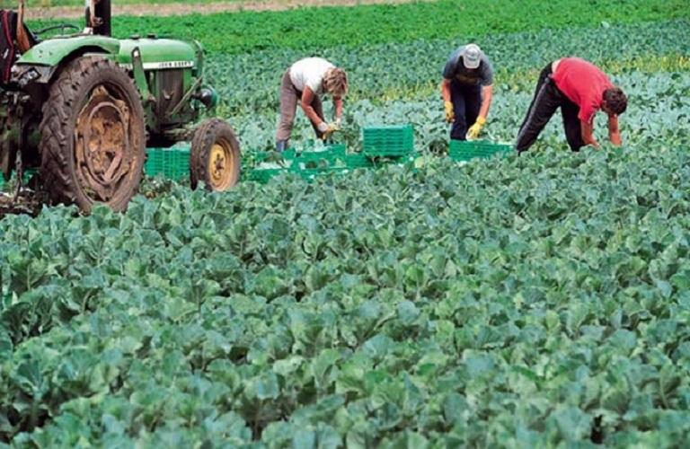

Fig. 9 Greek farmers (https://www.ot.gr/2023/03/10/english-edition/greek-farmers-sound-the-alarm-over-land-worker-derth/ )

Highlight the co-benefits
Carbon storage farming practices are not just good for mitigating climate change- they
come with a host of co-benefits for the farm itself (Amin et al., 2020).

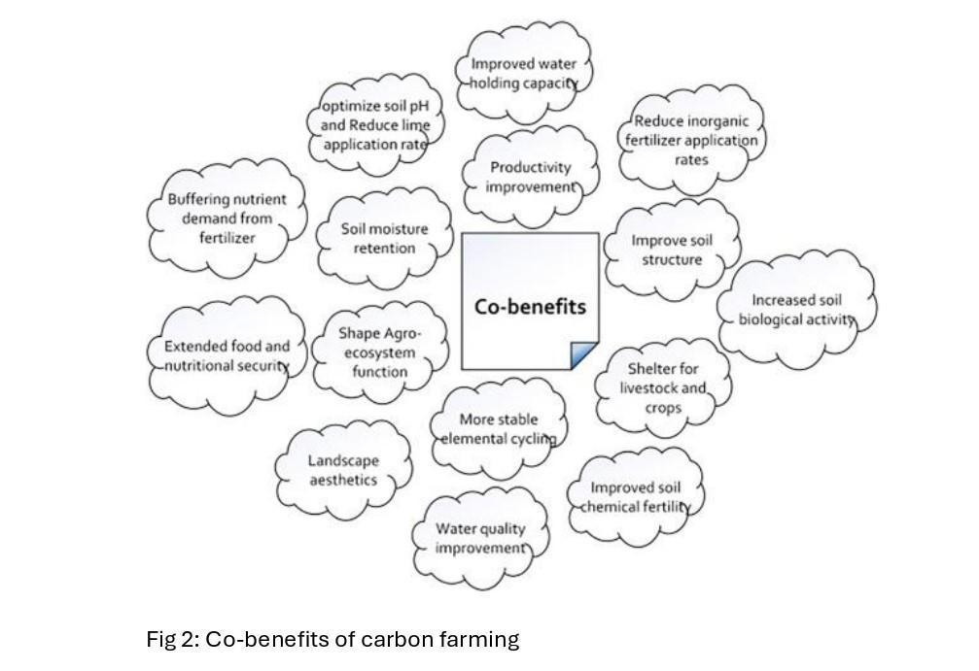
Fig 10: Co-benefits of Carbon Farming (https://www.sciencedirect.com/science/article/abs/pii/S0048969719351745?via%3Dihub)

Use the farmers’ peer example

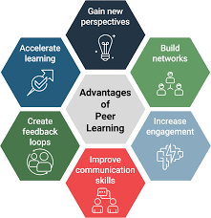
Psychological research has long shown that individuals are influenced by the behavior of others, including their perceptions of how others behave. Recent studies, such as those by Kropf and Mitter (2022), have indicated that farmers who are part of professional agricultural networks, engage in knowledge-sharing with peers, and visit other farms are more inclined to adopt climate change mitigation measures like carbon farming. Additionally, the frequency and quality of interactions with fellow farmers play a significant role in shaping individual farmers' behaviors in this regard.

Fig 11: Peer Learning
(https://instructionaldesign.com.au/peer-learning-shared-learning/)

Communicate it effectively

While expert advice, such as guidance from natural resource managers, has been shown to significantly influence farmers' adaptation behavior, effectively communicating about soil carbon management presents specific challenges. Many promotional messages focus on the scientific potential of practices to enhance carbon sequestration. However, some stakeholders perceive interest in soil carbon as driven primarily by a political climate change agenda, which may not always align with farmer interests, priorities, or beliefs. These perceptions create issues regarding the credibility, relevance, and consideration of scientific information in the everyday lives and priorities of the farming community.

A research project investigating carbon farming uptake in five European regions based on stakeholder consultations, concluded that effective information on carbon farming must be "credible," "salient" (i.e., relevant to users' needs), and produced in a "legitimate" manner (Ingram et al., 2016). For a more detailed explanation of each concept, refer to Figure 12.

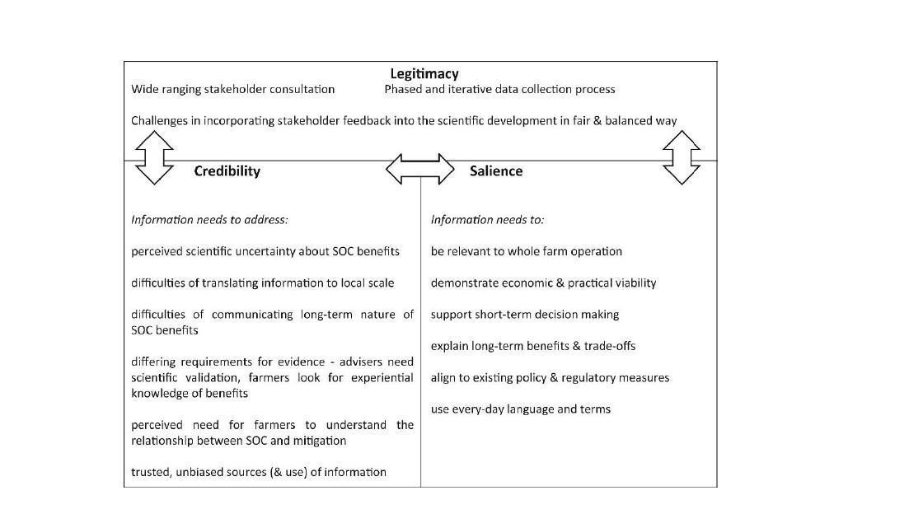

Fig 12: Dimensions of credibility, salience and legitimacy concerning information on soil carbon management (https://linkinghub.elsevier.com/retrieve/pii/S0743016716304922 )

Address the diversity of motivations

Farmers' reasons for embracing environmentally friendly practices like carbon farming are varied and shaped by a combination of attitudes, preferences, values, and objectives. Effectively conveying the message is facilitated by understanding the mindset of the audience. Farmers' decisions regarding beneficial agro-environmental practices are not solely driven by environmental concerns. For instance, a comparison of farmers in the UK and Canada revealed that while many prioritize environmental considerations, their choices are also influenced by various other factors. These factors include a "lifestyle" orientation, where farmers seek personal benefits such as recreation, health, and enjoyment from farm work; a "production" orientation, focused on increasing yield, productivity, and efficiency; a "business" orientation, which emphasizes environmentally beneficial decisions that may reduce production but enhance on-farm profitability, such as participating in agri-environmental schemes or pursuing value-added agriculture like organic certification; and a "farm health" orientation, where decisions are driven by factors benefiting the farm itself, such as maintaining its aesthetic, overall health, and sustainability for future generations (Marr & Howley, 2019).

Use appropriate promotional material

The effectiveness of communicating about carbon farming hinges on whether the message is customized to suit the requirements and characteristics of the target audience. Given the potential variations across different contexts, a one-size-fits-all approach is not suitable. Two commonly utilized and cost-effective informational resources are fact sheets and real-life Cases. Fact sheets cater to individuals who prefer evidence presented in terms of validated causal relationships and scientific principles. On the other hand, Real-life Cases are designed for those who prefer experiential evidence. Two examples of such materials, drawn from an actual soil carbon project and developed in consultation with participating farmers (Ingram et al., 2016), are illustrated in Figure 13.
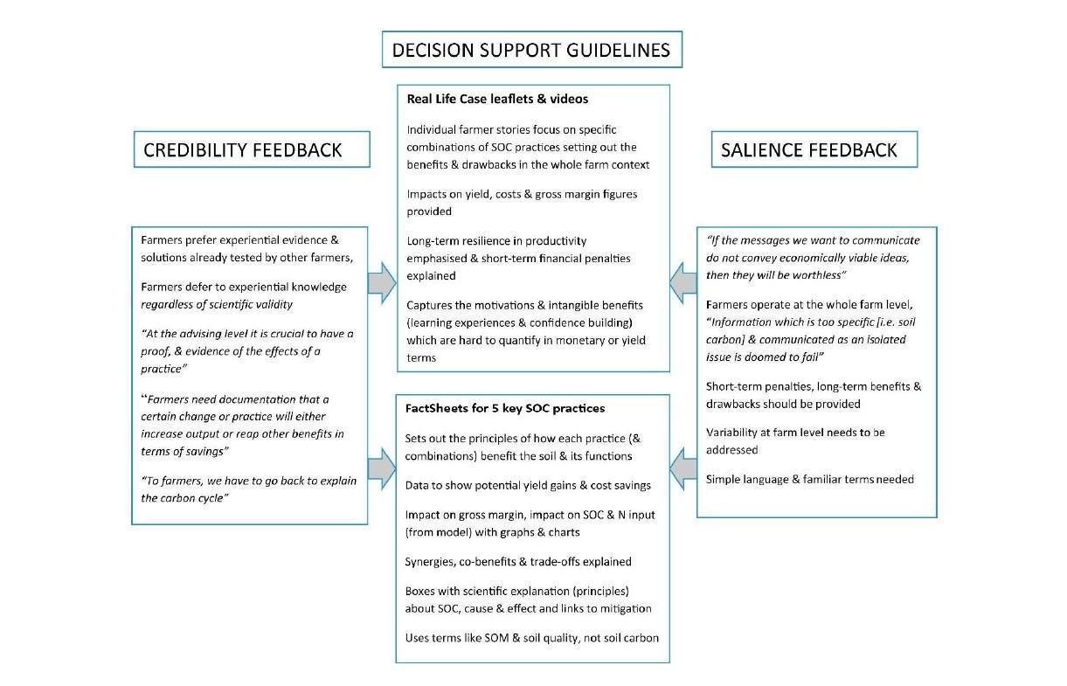

Fig 13: Development of decision support guidelines according to stakeholder perspectives on credibility and salience. (https://linkinghub.elsevier.com/retrieve/pii/S0743016716304922 )

It is worth noting that the importance of salience and credibility in developing effective informational material has been stressed even in the case of digital means, such as videos and podcasts (Chivers et al., 2023).

Prior EU-level projects on Carbon Farming

The European Union is constantly trying to face the challenge of climate change and environmental degradation through policies, frameworks and strategies. The main EU strategies to support the green transition in the agricultural sector are:
- European Green Deal - comprehensive strategy aimed at transforming the EU into a climate-neutral continent by 2050. It covers various sectors, including agriculture, and aims to promote sustainable practices, reduce greenhouse gas emissions, and protect biodiversity.
- Farm to Fork Strategy - aims to make food systems fair, healthy, and environmentally-friendly. It addresses the entire food supply chain, from production to consumption.
- Common Agricultural Policy Reform - long-standing EU policy that supports farmers and promotes rural development. The recent reforms are designed to align the CAP with the Green Deal objectives.
- Biodiversity Strategy for 2030 - strategy that aims to halt biodiversity loss in Europe and help restore natural ecosystems. It includes specific measures to protect and enhance biodiversity in agricultural landscapes.
- Climate Action Strategy - strategy that targets to reduce greenhouse gas emissions by at least 55% by 2030, compared to 1990 levels. The agricultural sector plays a crucial role in achieving these targets.
The above are some examples of EU environment and sustainability strategies regarding also the agricultural sector that is of reference for this project. Below there are relevant EU funded projects that can be of interest.

SmartSOIL

SmartSOIL (Sustainable farm Management Aimed at Reducing Threats to SOILs under climate change) was a research project in the European Commission Seventh Framework Programme (2011-2015). It ran in Poland, Hungary, Italy, Spain, Denmark and the UK. Its aim has been to contribute to reversing the current degradation trend of European agricultural soils by improving soil carbon management in European arable and mixed farming systems covering intensive to low-input and organic farming systems.

Interreg North Sea Carbon Farming

The Interreg North Sea Carbon Farming ran between Sep 2018 and Aug 2021 to promote Carbon Farming in the North Sea Region, by implementing carbon sequestration (CS) techniques on farm-level but also by facilitating collaboration between farmers and interested parties, in- and outside the food chain.

LIFE CarbonFarmingScheme

The goal of the LIFE CarbonFarmingScheme project was to identify and accelerate the development and adoption of novel incentives for carbon sequestration and the increase and maintenance of the organic carbon stock in soil and biomass in Europe. It ran between 2020 and 2022.

Interreg Central Europe Carbon Farming

The Interreg Central Europe Carbon Farming is running between April 2023 and March 2026 to promote Carbon Farming in the Central Europe Region. The countries involved are: Slovenia, Poland, Hungary, Italy, Austria, Croatia, Germany, and Czechia.

LIFE Carbon Farming

The LIFE Carbon Farming project aims to encourage farmers to adopt strategies to reduce their carbon footprint and increase carbon storage in vegetation and soils. It runs in France, Spain, Italy, Ireland, Belgium and Germany. The project is co-funded by the LIFE Programs of the European Commission Grant Agreement: LIFE20 CCM/FR/001663 (1/10/2021 – 1/10/2027).

Carbon Farming Projects Inventory

An Inventory of the latest Carbon Farming projects in Europe, compiled by the Institute for European Environmental Policy. The inventory includes predominantly projects funded by the Horizon Europe program, with a small selection of projects financed by other sources of public funding at the EU level, as well as private sector initiatives. Projects have been selected based on their potential to contribute to climate mitigation or resilience, and a low risk of directly undermining other environmental objectives. The inventory also includes projects that do not state climate mitigation as their main aim but are likely to yield climate benefits based on the employed practices. All projects are either ongoing or have been finalized in the last five years.

OrganicClimateNET

The initiative aims to establish a pilot network of 250 organic farms located in 12 EU countries to test, improve and implement knowledge on sustainable agricultural practices and carbon farming. It runs in Belgium, France, Germany, Spain, Poland, Finland, Ireland, Portugal, Romania, Latvia, Italy, the Netherlands, Estonia and Switzerland. The project is co-funded by the European Union´s Horizon Europe research and innovation programme under grant agreement No. 101136880 (01/02/2024- 31/01/2028).

3 Outreach Strategy

3.1 Objectives
The main objective of the Outreach Strategy is to provide ways for involvement and engagement of the project’s target group in the awareness-raising events that will be designed and described in this document, and further implemented as part of WP3.

The Strategy is designed and implemented by applying participatory approaches, allowing to:
● inform the target group about the project and its objectives
● make project information easily accessible and understood by the target group
● engage the target audience to participate in the activities
● provide guidelines on the above in collaboration with Ecovalia
● get feedback on how to better reach out by relevant stakeholders

3.2 Target Group

The main target groups of the Carbon Farming Awareness Hub project are:

1. Young people who are interested in sustainable agriculture and new business models tied up to the evolution of the primary sector, and especially in the emerging carbon market, are willing to become entrepreneurs in the sector. It includes skilled young people who have studied agriculture and wish to acquire new knowledge or reskill themselves; as well as young people who have non-formal competencies, non-academic studies and more practical capabilities in agriculture, who will upskill themselves.

2. Farmers wishing to convert their transitional farms into organic or to implement practices that reduce greenhouse emissions or increase the soil carbon sequestration, those who think that leaving conventional and very impacting production systems behind is important to securing the future of their farm, respecting the environment for a better quality of life and a better world for everyone.

3. School systems, such as secondary technical institutes.

Other targets for the creation of sustainable multi-stakeholder networks are:

1. Experienced farmers who wish to share their expertise with young aspirants in order to up-skill them and cooperate with them. They will have a highly skilled colleague with whom they can work together for the joint development of their businesses, by exploiting emerging opportunities together.

2. Relevant stakeholders – local, regional and international stakeholders, associated partners, private stakeholders (companies, BSOs, NGOs, Youth organizations) and public ones (Municipalities, local/regional public authorities in charge of community and territorial development). They will be involved in the project through targeted communication and dissemination actions (disseminating events, digital communication strategy).

3. Policymakers at a local and regional level. The project will focus on involving young, elected members of local municipalities and regional councils who might adopt and promote carbon farming.

3.3 Ways to reach out

3.3.1 Methods & tools
The following methods have been effective practices also counting that different methods and tools can be chosen according to each participant's group, in each country. The identified methods for reaching out to stakeholders are as follows:

Policymakers:
- Face-to-face meetings and seminars at local, regional and national level to promote the project activities and to share opportunities offered by the CarboFarmHub project with the targeted group of young people and farmers
- Participation in meetings and events of public bodies to share opportunities offered by the CarboFarmHub project to the targeted group of young people and farmers
- Involvement of public and local authorities in online project channels and website

Tools:
- Website
- Social media platforms
- Updated project events calendar online
- Digital and paper flyers in different languages

Relevant stakeholders:
- Face-to-face meetings and seminars at local and regional level: to promote the project activities and to share opportunities offered to the targeted group of young people and farmers
- Training seminars with AE professionals and volunteers to reinforce their knowledge on the topic of carbon farming
- Participating in Events: participating in local events with partners, setting up a stall and interacting with people to engage communities
- Promotion through employers’ organisations to increase the visibility of the project
- Social Media campaign

Tools:
- Website
- Social media platforms
- Updated project events calendar online
- Digital and paper flyers in different languages
- Drafted communications to schools, social services, municipalities, etc. to convey the project messages

With regards to the specific actions addressed to young people and farmers, a three-level strategy can be followed:
1) Informal level to make people aware of the opportunities offered by the project:
- support and promote word of mouth among target groups to inspire and encourage the involvement in the project activities
- community level activities to spread the project message
2) Formal level
- promotion through municipal services
- promotion through employers’ organisations to increase the visibility of the project
3) Social media level
- promotion of the project at all levels (national, regional, local) through social media
- promotion of the project trough partners’ websites

Framework of Initiatives

The Global Framework of initiatives for the CarboFarmHub, as mentioned above, contains 10 awareness-raising and non-formal training initiatives for youngsters and stakeholders that will be piloted in the different partner countries and online, according to a hybrid delivery model.
According to the project application, each partner should implement at least 3 of the described initiatives and in total at least 10 of the implemented activities should be done online.

Initiative 1 – Carbon Farming: Tradition meets today (proposed by: NANG)

Description
Creating short video content in the local language (you can add english subtitles) that includes interviews with seasoned, elder farmers as well as younger producers, aiming to explore various aspects of carbon farming.

Purpose
The purpose of creating the above videos is to disseminate knowledge and experience regarding carbon farming, bridging tradition with the present. The videos will focus on showcasing the expertise of farmers employing traditional cultivation techniques and their openness to adopting new carbon reduction practices. Concurrently, through interviews with young farmers utilizing modern methods, innovative approaches to carbon farming will be highlighted. In this manner, the videos aim to encourage viewers to draw insights from tradition and embrace innovative strategies for advancing carbon farming, enriching the dialogue surrounding sustainable agriculture.

Implementation
* Identify Participants: We will reach out to older farmers who have extensive experience in agriculture. It’s not necessary to have experience in carbon farming techniques. Similarly, we will connect with younger producers.
* Film Interviews: Record the interviews with high-quality video and audio equipment to ensure clarity and professionalism. Consider filming at the farmers' locations to provide context and authenticity to the content.
* Promotion and Distribution: Once the videos are ready, create a promotional strategy to reach your target audience. Utilize social media platforms, agricultural forums, and relevant communities to share the videos widely. We will use NANG’s digital platform “Cultivate” to share the videos with all. Upload to online platforms (YouTube, social media) and promotion through social media and newsletters.
* Track key metrics such as views, engagement, and audience demographics to assess the impact of your video content. Analyze the data to understand what resonates with your audience and adjust your approach accordingly. It is very important to track the dissemination of the video.

Target group
* Young people who are interested in sustainable agriculture and new business models tied up to the evolution of the primary sector, primarily in the emerging carbon market, aspiring to become entrepreneurs in the sector.
* Young farmers who would like to convert their traditional/conventional farms into organic, or to implement practices that reduce greenhouse emissions or increase soil carbon sequestration.
* Experienced farmers who would like to share their expertise with young aspirants and would like to update themselves regarding novel business and networking opportunities.
* Relevant stakeholders – local, regional and international stakeholders, including associated partners (companies, BSOs, NGOs, Youth organisations) and public ones (Municipalities, local/regional public authorities in charge of community and territorial development).

Expected results
Through this initiative, we aim to increase awareness and enrich the dialogue surrounding sustainable agriculture. The dissemination of informative videos on carbon farming is likely to raise awareness among farmers and the general public about the importance and benefits of sustainable agricultural practices. This initiative aims to share knowledge from experienced farmers and young producers, leading to a more informed and educated farming community. The initiative can foster a sense of community among farmers, encouraging collaboration, networking, and the exchange of ideas. This could lead to the formation of support networks and partnerships focused on advancing carbon farming initiatives. Increased awareness and support for carbon farming could influence agricultural policies at local, regional, or national levels. Policy changes or incentives that promote sustainable farming practices may be introduced as a result of heightened advocacy and public awareness.

Guidelines for implementation
Define themes and questions: The scope of the videos is to explore various aspects of carbon farming. Each interviewer will answer four relevant questions. Depending on the background, we have to define the questions.
Length of the video: 2 - 5 minutes.
Technical Characteristics:
- Clear sound is needed, and wind protection.
- Leave 1-2 “empty” seconds at the beginning and at the end of each scene.
- While recording, keep your smartphone horizontal for better viewing.
- Take note of the main data related to the video (time, place, topic, speakers) as soon as possible.
- Before producing a video, please make sure that all individuals shown in the video have given their written consent to be filmed/recorded and that their personal information can be used and stored according to the General Data Protection Regulation (GDPR).
Dissemination: Upload to platforms “Cultivate Academy”, YouTube, social media and promotion through social media and newsletters.

Initiative 2 – Participatory Carbon Farming: Photographic competition (proposed by: NANG)

Description
Organizing a virtual participatory photographic competition.

Purpose
Participatory photography offers a dynamic avenue for individuals to convey their perspectives and aspirations through visual storytelling. In light of this, organizing a Participatory Carbon Farming Photographic Competition is an approach that will empower participants to capture the essence of carbon farming, share their unique narratives, and contribute to the broader dialogue on sustainability and environmental stewardship. The primary objective of this competition is to democratize the narrative surrounding carbon farming and foster community engagement. By embracing participatory photography, we aim to provide a platform for diverse voices to articulate their visions of sustainable agriculture and its impact on our planet.

Implementation
For the implementation of the participatory carbon farming photographic competition, several key steps will be undertaken. Firstly, the theme of the competition will be clearly defined, focusing on various aspects of carbon farming such as regenerative agriculture practices, soil health improvement, carbon sequestration, biodiversity enhancement, and community involvement. This comprehensive theme aims to inspire participants to capture diverse perspectives and narratives related to sustainable agriculture and carbon farming. Secondly, extensive participant engagement strategies will be employed to ensure inclusivity and diversity among participants. Efforts will be made to encourage involvement from farmers, environmental activists, students, photographers, and community members, allowing for a broad spectrum of perspectives to be represented. Thirdly, clear guidelines and rules will be developed, outlining submission criteria, image specifications, eligibility criteria, deadlines, and any other pertinent information. These guidelines will provide participants with the necessary structure to effectively participate in the competition. Additionally, efforts will be made to promote the competition through various channels such as social media, local community networks, environmental organizations, and educational institutions, facilitating widespread outreach and participation.

Prize: Here are some ideas for the winner's prize, but each partner has to define the prize before the announcement of the competition. The winner will have to accept one of the following prizes:

- Winner’s gallery on the project's website
- Social media posts for the winners
- Invitation to participate in an awareness-raising activity
- Invitation to a meeting

Target group
* Young people who are interested in sustainable agriculture and new business models tied up to the evolution of the primary sector, primarily in the emerging carbon market, aspiring to become entrepreneurs in the sector.
* Young farmers who would like to convert their traditional/conventional farms into organic, or to implement practices that reduce greenhouse emissions or increase soil carbon sequestration.
* Experienced farmers who would like to share their expertise with young aspirants and would like to update themselves regarding novel business and networking opportunities.
* Relevant stakeholders – local, regional up to international stakeholders, including associated partners (companies, BSOs, NGOs, Youth organisations) and public ones (Municipalities, local/regional public authorities in charge of community and territorial development).

Expected results
The expected results of implementing the Participatory Carbon Farming Photographic Competition are multifaceted. Firstly, by encouraging participation from diverse groups such as farmers, environmental activists, students, photographers, and community members, the competition aims to foster a sense of ownership and engagement in sustainability initiatives within communities. This inclusive approach is expected to promote dialogue, collaboration, and knowledge-sharing among participants, furthering the spread of sustainable practices beyond the competition itself. Secondly, the competition is anticipated to generate a rich and diverse collection of photographs showcasing innovative approaches to carbon farming, soil health improvement, biodiversity enhancement, and community involvement. These photographs have the potential to serve as powerful educational tools, inspiring others to adopt similar practices and fostering a deeper understanding of the interconnectedness between agriculture, the environment, and society. Overall, the expected results of the competition include heightened awareness of sustainable agriculture practices, increased community engagement in environmental stewardship, a diverse collection of impactful photographs, and tangible benefits for participants. Through these outcomes, the competition aims to make a meaningful contribution to the broader dialogue on sustainability and inspire positive action towards a more resilient and sustainable future.

Guidelines for implementation
- Theme & Eligibility: Clarify the theme, for example Carbon Farming - Capture sustainable farming practices.
- Submission Period & winner announcement must be defined
- Submission Guidelines: for example up to three JPEG photos per participant and high resolution (minimum 300 dpi)
- Submission Process: Google form, digital online platform etc
- Judging Criteria: Originality, composition, technical quality
- Prizes: each partner will define the prize.

Initiative 3 – Questionnaires on Carbon Farming Management (proposed by: Centoform)

Description
Surveys are to be devoted to sectoral stakeholders (farmers, farmers’s organizations, BSOs, etc.).

Purpose
Collect information regarding the state of development and application at the local level/at organizational level of carbon management practices, including detecting results, perceived and obtained benefits. Strongly connected to best practices and with a focus on regional levels.

Implementation
The guidelines will include the questionnaire(s) to be distributed and information on the targets to be reached. The main idea will be to spread the questionnaire/s through online tools to facilitate sharing and elaboration of results/feedback.

Target group
Main stakeholders operating in the agrifood sector/primary sector deal with innovation, new practices and business models. The contribution of a wide panel of stakeholders will help engage the ecosystem level.

Expected results
This initiative is aimed at involving the main relevant regional stakeholders (private and public), by inviting them to actively contribute to the design an overall picture regarding the state of development and application of carbon management practices and models. And to invite these stakeholders to suggest how to increase awareness and knowledge about the topic to existing farmers, aspiring ones and young generations at the community level as well.

Guidelines for implementation
Preparation: the survey should be developed in an online/digital format to facilitate data collection and further analysis, comparison and elaboration. To develop the survey in digital format some tools to be used might be the following: GoogleModules, Kahoot, Menti, SurveyMonkey,or similar. Choose the tool you prefer, what is relevant is the following:
- capacity of the tool to extract collected data, for example in excel or csv formats;
- capacity of the tool to visualize collected data through graphs/infographics
- Capacity of the tool to provide flexible and customized layouts, to increase the attractiveness of the surveys for respondents.

Promotion and spreading: Once developed, the survey has to be promoted through different communication channels (social media, web sites, but also word-of mouth, onsite sectoral events, in-house organs, newsletters, etc.) to reach the widest number of potential respondents. The dissemination of the survey should be accompanied by a clear and focused message with concise information to the purpose, what is requested by respondents, the fact that all the information collected will be treated as anonymous data, the use of collected data, etc. be clear in setting a deadline to collect feedback and data.

Analysis and reporting: after collection of data and relevant information from the main target groups, it is time to analyze the results/findings, to further elaborate them, for example through comparative checks, depending on the aims of the analysis itself. The final reporting should prefer visualizations, the use of graphs and infographics to show the main findings. The visuals result in more effective, immediate and understandable for any stakeholder. The reporting might be done in the form of a presentation/animated presentation or through a written text file, with integrated tables, images, and infographics. The digital format in word and pdf or similar, can support online publication on the web sites or the dissemination through the social media, making it easier for anyone potentially interested to access the document.

Initiative 4 – Roundtables: Q&A with professionals (proposed by: Ecovalia)

Description
Organise a series of virtual workshops and roundtable discussions focused on exploring effective strategies in carbon-neutral farming. These events aim to inspire and facilitate interaction among participants, fostering valuable exchanges between young farmers interested in transitioning to organic, environmentally friendly methods and experienced agricultural professionals. Through these platforms, individuals are provided with the resources and insights needed to contribute to a more sustainable agricultural landscape, reducing carbon emissions and mitigating the effects of climate change.

Purpose
This participatory event aims to address carbon farming and foster the exchange of diverse experiences. Through interactive sessions, participants will have the opportunity to explore and share innovative practices in sustainable agriculture, with a particular focus on reducing carbon footprint. The event is designed to encourage collaboration and mutual learning among various stakeholders, from young farmers to experts in the field, to drive the adoption of more eco-friendly and climate-resilient agricultural practices. Is foreseen that enough of the experts will be organic farmers, as will have more experience in environmentally friendly and good practices in the farm management.

Implementation
Participant and Expert Selection: Identify and engage participants and experts suitable for facilitating workshops.
Workshop Organization: Organize workshops, including logistics, agenda development, and hybrid event possibilities for both in-person and virtual participation (if possible).
Engagement Activities: Incorporate interactive elements into workshops to encourage active participation and knowledge sharing among participants.
Result Compilation and Dissemination: Summarize workshop outcomes and insights, sharing them with participants and interested parties via social media, newsletters, and other communication channels.
Follow-up and Feedback: Gather feedback from participants to evaluate workshop effectiveness and inform future planning.

Target group
Young farmers who would like to convert their traditional/conventional farms into organic, or to implement practices that reduce greenhouse emissions or increase soil carbon sequestration.
Experienced farmers who would like to share their expertise with young aspirants and would like to update themselves regarding novel business and networking opportunities.

Expected results
Through the workshops and activities, our anticipated outcomes include the facilitation of knowledge exchange among participants on carbon farming, strengthening a network of stakeholders committed to sustainable agriculture. By disseminating insights and fostering collaboration, we aim to increase awareness and adoption of carbon farming practices, empowering stakeholders to play an active role in mitigating climate change impacts. Soliciting feedback and continuous evaluation will drive ongoing improvement, ensuring the long-term sustainability and impact of our efforts in promoting climate-resilient agriculture and fostering positive environmental change.

Guidelines for implementation
- Participant and Expert Selection: through local, regional and national farming associations/networks, agricultural schools, targeting young farmers interested in sustainable practices and engaging them with experienced/skilled farmers in organic and carbon neutral farming methods.
- Workshop Organization: a database will be created by the consortium to compile interesting topics about Carbon Farming, ensuring that the topics are diverse and differ from other initiatives, to be implemented in the Roundtables. The events will be held online at national levels to facilitate the communication between stakeholders. The content includes key topics like carbon footprint reduction and soil carbon sequestration. At the end, it is essential to incorporate Q&A sessions and interactive discussions.
- Engagement activities: use tools like polls, quiz games, and live Q&A to engage participants, and facilitate networking sessions for participants to share experiences.
- Result compilation and dissemination: create and share summary reports via social media, newsletters, and partner websites.
- Follow-up and Feedback: use surveys and feedback forms to gather participants feedback in terms of organisation, speakers and topics discussed. The results of the surveys will help to improve for future roundtables.

Initiative 5 - Webinars to educate target group on best practices (proposed by: AKEP, Agrobio)

Description
1-hour webinars with a strong educational and informative character can be organized via Zoom to explain the concepts, practices, and impacts and also share the best practices on Carbon Farming management found by the partnership. It will be part of the platform for sharing knowledge, best practices, and innovative techniques in carbon farming.

Purpose
* Educate youth, students and farmers about the importance of Carbon Farming management in mitigating climate change.
* Share insights and best practices from experts and partnerships involved in Carbon Farming.
* Empower participants with practical knowledge and tools to implement Carbon Farming practices effectively.
* Foster collaboration and networking among youth, farmers, and experts in the field of sustainable agriculture.

Implementation
We can start by planning a series of webinars (3-5 in total) that can cover different aspects of Carbon Farming management (soil health, crop rotation, agroforestry, livestock management, etc.). The webinars can be conducted in English and organized by the whole partnership, so we can have experts, researchers and practitioners invited from all partner countries. People invited can have a panel discussion, present case studies, research findings and success stories, using interactive tools to engage participants and make them more active. To engage the students effectively, the session will include interactive elements such as live polls and Q&A segments. Continuous feedback will be solicited through pre and post-webinar surveys to measure understanding and gather suggestions for improvement. The webinars should be recorded and uploaded to the platform, so they can be used as a future reference, but also as an asynchronous form of training, for people not participating in the webinars.

Target group
* Young people who are interested in sustainable agriculture and new business models tied up to the evolution of the primary sector, primarily in the emerging carbon market, aspiring to become entrepreneurs in the sector.
* Young farmers who would like to convert their traditional/conventional farms into organic, or to implement practices that reduce greenhouse emissions or increase soil carbon sequestration.
* Experienced farmers who would like to share their expertise with young aspirants and would like to update themselves regarding novel business and networking opportunities.
* Relevant stakeholders – local, regional up to international stakeholders, including associated partners (companies, BSOs, NGOs, Youth organisations) and public ones (municipalities, local/regional public authorities in charge of community and territorial development).

Expected results
The expected results can be summarized as follows:
* Increased awareness and understanding of Carbon Farming management practices.
* Enhanced capacity of youth and farmers to implement sustainable farming techniques that contribute to carbon sequestration and climate resilience.
* Strengthened networks and partnerships among stakeholders in the agriculture and environmental sectors.
* Adoption of Carbon Farming practices leading to tangible environmental benefits, such as improved soil health, increased biodiversity, and reduced greenhouse gas emissions.
* Empowerment of youth and farmers to become advocates for sustainable agriculture and climate action in their community.

Guidelines for implementation
Webinar 1: Organic Agriculture and Carbon Sequestration
Description: This webinar will focus on integrating organic farming practices into carbon farming, highlighting how organic methods can contribute to carbon sequestration and agricultural sustainability.
Topics: Principles of organic farming and its relationship with carbon sequestration.
Organic farming practices to improve soil health and increase organic matter.
Good agricultural practices that contribute to the reduction of greenhouse gas
emissions.
Case studies of successful organic farms implementing carbon sequestration
practices.
Webinar 2: Biodiversity and Carbon Farming
Description: This webinar will explore how promoting biodiversity on farms can contribute to carbon sequestration and environmental sustainability.
Topics: Importance of biodiversity for soil health.
Agricultural practices that increase biodiversity.
Integration of natural habitats and ecological corridors into agricultural
landscapes.
Case studies on biodiversity and carbon sequestration.
Webinar 3: Soil Health and Carbon Sequestration
Description: This webinar will focus on the importance of soil health and how specific agricultural practices can enhance soil's capacity to sequester carbon.
Topics: Introduction to the concept of soil carbon sequestration.
Soil management practices that promote carbon sequestration (e.g., soil cover,
green manure, composting).
Impact of soil organic matter and techniques to increase organic matter.
Case studies and practical examples of successful soil health management for
increased carbon sequestration.

Initiative 6 – MOOC course: Knowledge pills on organic farming (proposed by: Ecovalia)

Description
This initiative provides a specialized course focused on the benefits of Organic Farming for Carbon Farming (Climate change). Utilizing existing video content from StartupBio Home - Start Up Bio, the course delivers concise "knowledge pills" designed to empower aspiring farmers with practical insights and strategies for implementing organic farming techniques. Participants will explore the nexus between organic agriculture and carbon sequestration, learning how these practices contribute to mitigating climate change impacts while enhancing soil health and biodiversity. With this process, the project will provide feedback to another Erasmus+ project, the StarUpBio, further enhancing collaborative efforts in sustainable agriculture.

Purpose
The purpose of this initiative is to equip young farmers with essential knowledge and insights to facilitate informed decisions regarding the transition to organic farming practices. Through the specialized course, participants will gain a comprehensive understanding of the benefits of organic farming, empowering them to make sustainable choices that contribute to environmental conservation and long-term agricultural resilience.

Implementation
The implementation plan involves creating at least three short videos on organic farming's significance, its EU regulation, its benefits, and its relationship with carbon farming. These videos will serve as an introduction to the more detailed and developed videos already created under the previous Erasmus + projects, StarUpBio. These videos (filmed ideally on farms demonstrating effective organic and carbon farming practices) will be translated or subtitled into consortium members' languages. Targeted outreach strategies will disseminate these videos to young farmers through social media, online platforms, newsletters, and local agricultural associations.

Target group
* Young farmers, who would like to convert their traditional/conventional farms into organic, or to implement practices that reduce greenhouse emissions or increase soil carbon sequestration.
* Farmers wishing to convert their transitional farms into organic or to implement practices that reduce the greenhouse emissions or increase the soil carbon sequestration, those who think that leaving conventional and very impacting production systems behind is important to securing the future of their farm, respecting the environment for a better quality of life and a better world for everyone.

Expected results
The expected outcomes include an increase in the number of farmers transitioning to organic farming practices. This shift towards organic agriculture is anticipated to contribute to environmental sustainability by enhancing soil health and promoting biodiversity. Additionally, it is expected to lead to improved resilience to climate change and greater carbon sequestration, thereby fostering a more sustainable and resilient agricultural landscape.

Guidelines for implementation

- Create short videos on organic farming’s significance
- Location: farms that already implement sustainable practices

Initiative 7 – Field visits (proposed by: Theophrastus)

Description
Local field visits can be organized to educate and raise awareness among youth and farmers about sustainable farming practices. These visits will involve guided tours of farms that implement effective organic and carbon farming methods, for example it can take place in an olive oil production unit.

Purpose
The primary purpose of these field visits is to provide participants with firsthand experience and practical insights into the benefits and techniques of carbon farming. By observing real-world applications, attendees will better understand how these practices contribute to environmental sustainability and agricultural productivity. It will be a practical way to ‘’connect the dots’’ between what they know in theory on carbon farming and how various practices are already being implemented on a local level.

Implementation
Planning: The initial step is to plan how the activity can take place on a local level. Partners willing to conduct field visits will have to find available farms, contact the owners and organise how the activity can take place (dates, timing, demonstrations useful for the beneficiaries)
Promotion: Partners are free to invite people from their network to participate, students of the agricultural departments, farmers or even create Social Media campaigns that will bring more visibility to the local communities.
Execution: Organisers might have an introductory meeting with the participants, so as to explain the activity and give a first taste of the project. Simultaneously, a good idea would be to prepare informative material in collaboration with the farmer to be handed out on the spot.

Target group
* Young farmers who are undecided about adopting organic and carbon farming practices.
* Agricultural students and local youth interested in sustainable agriculture.
* Local farmers and agricultural professionals seeking to learn about innovative farming methods.

Expected results
The expected results of the field visits can be summarized as follows:
* Increased awareness and understanding of carbon farming practices among participants.
* Enhanced interest and motivation to adopt sustainable farming techniques.
* Strengthened connections between young farmers, agricultural experts, and local communities.
* Creating a network of farmers and participants.
* Improved knowledge sharing and dissemination of best practices in organic and carbon farming.

Guidelines for implementation

- Identify potential partners - farms (state the benefits for both parts).
- Develop a clear agenda with regards to timing and active participation.
- Provide clear instructions and schedules to participants beforehand.
- Ensure all demonstrations are practical, relevant, and easy to understand - devote time to an interactive Q&A
- Provide additional resources and contacts for further learning.
- Gather feedback from participants to assess the effectiveness of the visits

.

Initiative 8 – Podcasts (proposed by: AKEP, Centoform)

Description
The podcast series (3-5 episodes lasting 20 minutes) aims to provide informative and engaging discussions on Carbon Farming management practices, featuring experts, practitioners, and stakeholders in the field. Each episode will delve into different aspects of Carbon Farming, sharing insights, stories, and practical tips for sustainable agriculture.

Purpose
Main purpose will be to raise awareness of the importance of carbon farming management in addressing climate change, inform and educate listeners on innovative techniques in the EU, but also to share inspiring success stories among practitioners. Another goal will be to facilitate knowledge exchange and networking opportunities among stakeholders interested in sustainable agriculture and climate resilience.

Implementation
* Plan the series of podcast episodes covering different topics related to carbon farming (e.g. regenerative agriculture, soil health, agroforestry etc.).
* Invite guests to share their expertise, experiences and insights on the topic (researchers, farmers, policymakers, and activists).
* Use the format of interviews, discussions and storytelling to make complex concepts accessible and engaging.

Target group
* Young people who are interested in sustainable agriculture and new business models tied up to the evolution of the primary sector, primarily in the emerging carbon market, aspiring to become entrepreneurs in the sector.
* Young farmers who would like to convert their traditional/conventional farms into organic, or to implement practices that reduce greenhouse emissions or increase soil carbon sequestration.
* Experienced farmers who would like to share their expertise with young aspirants and would like to update themselves regarding novel business and networking opportunities.
* Relevant stakeholders – local, regional up to international stakeholders, including associated partners (companies, BSOs, NGOs, Youth organisations) and public ones (Municipalities, local/regional public authorities in charge of community and territorial development).

Expected results
* Increased awareness and knowledge among the target audience about the principles, benefits, and challenges of Carbon Farming management.
* Empowerment of listeners to take action towards implementing sustainable farming practices in their communities or supporting initiatives promoting Carbon Farming.
* Formation of a community of practice and collaboration among stakeholders interested in advancing Carbon Farming and sustainable agriculture.
* Amplification of voices advocating for policy changes and investments to support Carbon Farming initiatives at local, national, and international levels.
* Long-term impact on agricultural landscapes, biodiversity conservation, and climate resilience through the widespread adoption of Carbon Farming practices.

Guidelines for implementation
Preparation: to deliver a successful Podcast, it is necessary to get prepared very well.
More in detail:
I. It is important to think about the layout, for example a front image, that will remain alongside the whole Podcast Series, to make listeners better remember the “authors” of the products. To customize an attractive layout, and /or to find some ready-to-use models, our suggestion is to use Canva or similar programmes, free of charge.
II. Then it is crucial to prepare the environment: choose a silent place where recording, with no background noise!
III. To be sure to record in a very fluent way, it is recommended to prepare a script for the text/message.
IV. According to the target audience, try to customize the duration of your Podcast, for example, it is better not to overcome the 20-30 minutes of duration of each audio.

Recording:
- By using the script and after choosing a quiet location and after checking the correct functionalities of the microphones, it is time to start with the recording. Remember to breathe, not to speak too fast, try to have a good and clear pronunciation and, last, but not least, remember to make some pauses. The use of pauses and the variation of the timbre of voice can help make the Podcast easier to be followed/listened to and more engaging for the listener.
- At the very beginning of your recording, remember to introduce the main faced topic/s and to make explicit the number of the Podcast (in case of a series) (INTRODUCTION). Then at the end, remember to wrap up, launching, in the case of a series, the next appointment/”episode” (CONCLUSION).
- To record and finalize a Podcast or a Podcast series, there are many free of charge programmes that might be used, for example:

  - Shortcut,a free, open source, cross-platform video editor, useful both during design, development and assembly of images and recordings.
  - Animaker, free, open source, AI based tool for non professionals video makers and podcasts: if you do not like your recorded voice, you can choose some very professional options here!

Some examples to start:

https://www.youtube.com/playlist?list=PLTHNp74i9N1kw5p5zmcwWzz4Ij8KeNWHr

https://e-participationyouth.eu/2021/11/24/post-1/

Initiative 9 – Dissemination actions with farmers (proposed by: Agrobio)

Description
Integration of Carbon Farming information into the Organic Agriculture Dissemination monthly sessions held by Agrobio, using presentations, discussions, and practical demonstrations. These dissemination actions consist of events organized between AGROBIO and local Associations with the aim of bringing experts, farmers and decision-makers from the region. The events will be held in different locations across the country.

Purpose
Educational and practical, aimed at teaching the fundamentals of Carbon Farming and encouraging its adoption to enhance sustainability and combat climate change. Providing information and educating participants about innovative techniques and the benefits of carbon farming, adapting them to the local context in order to facilitate their application.
Frequency: 1 action per month
Implementation
Appropriate content includes incorporating relevant and scientific content about Carbon Farming into existing sessions. Dissemination action involves preparing speakers to clearly explain the concepts of Carbon Farming. Interactivity will be ensured by using demonstrations and case studies to exemplify practical application. Continuous feedback will be established through evaluation mechanisms to refine future sessions.

Target group
The primary target group consists of organic farmers, focusing on the practical application of knowledge. The secondary target includes educators, students, and the local community, aimed at broader dissemination and increased awareness.

Expected results
The expected outcomes include a greater understanding and implementation of Carbon Farming practices among organic farmers. This should lead to a reduction of the carbon footprint in agriculture and improved soil health. Additionally, the initiative aims to develop a supportive base for sustainable agriculture through enhanced community engagement.

Guidelines for implementation
1) Preparation: Contact Agrobio's various partners (local associations/partners) to bring together experts and farmers from the region to take part in the events;
2) Development: Develop program adapted to each region visited, with instructions and indications of the subjects covered, time and place of the event;
3) Promoting the events: through our media and through local associations/partners;
4) Outcome: Share technical and practical knowledge about carbon farming through presentations and field visits.

Initiative 10 – Celebration of Organic Agriculture and Carbon Farming: Carbon Farming Management (proposed by: Agrobio)

Description
Organize a Congress to celebrate Organic Agriculture and Carbon Farming, focusing on Carbon Farming Management, in partnership with a university. This event will include expert discussion panels, and practical demonstrations to showcase best practices and the benefits of integrating Carbon Farming into Organic Agriculture.
Will be attended by speakers from different fields of work, such as researchers, farmers and policy-makers, who will be able to pass on their experience and knowledge to the participants.

Purpose
The aim is to raise awareness about the importance of Carbon Farming within the context of Organic Agriculture, promoting methods that maximize carbon sequestration and agricultural sustainability. The event also seeks to create a platform for knowledge exchange and experience sharing among farmers, academics, and industry professionals. The participation of different speakers will allow us to go deeper into the topic of Carbon Farming and it will give participants an overview of how to apply carbon farming and what challenges they may face.

Implementation
The event will be organized around a series of interactive and educational activities. It will feature expert presentations on the latest research and innovations in Carbon Farming, roundtable discussions on sustainable policies and practices, and live demonstrations to illustrate effective carbon management techniques in the field. Participant feedback will be collected through surveys and feedback sessions to guide the organization of future events.

Target group
Organic farmers, sustainability experts, agricultural science students, and policymakers will be the primary audience. The event is designed to be highly inclusive and interactive, encouraging active participation and open dialogue among all attendees.
considering that this Congress is being held at a university means that most of the participants will be young farmers or future farmers.

Expected results
The event is expected to increase awareness and knowledge about Carbon Farming, leading to broader adoption of these practices among organic farmers. It’s also expected that young people will feel inspired to adopt the principles of carbon farming to encourage its practice in the community. Additionally, the event should strengthen networks among participants, fostering future collaborations and joint initiatives that support the transition to more sustainable, carbon-rich agricultural practices.

Guidelines for implementation
1) Participant and Expert Selection: through local associations and partners, seek out a group of experienced producers, researchers and policy-makers who can share their work with the audience.
2) Seminar Organization: The event will be organized in partnership with a university, where we will have their participation and collaboration. Topics such as Organic Farming and Carbon Sequestration; Biodiversity and Carbon Farming; Soil Health and Carbon Sequestration will be covered. The event will include Q&A sessions and interactive discussion between the participants and the speakers.
3) Feedback: Carry out surveys to gather feedback from participants on the organization, topics discussed and speakers.

Digital CarboFarmHub

I. A dedicated space for collaboration, exchange, and fruition of the various online/hybrid initiatives will be set up to guarantee large visibility and full accessibility for all interested people.
II. The online platform Cultivate will be utilized to showcase and disseminate the results of these tested initiatives. Cultivate will serve as the central hub, providing a comprehensive environment where participants can share insights and resources, such as research papers, project reports, case studies, and best practices. This repository of knowledge will be available to all, ensuring that valuable information is widely shared and utilized. The platform will highlight the outcomes of different initiatives through detailed presentations, webinars, and interactive content, celebrating successes and offering learning opportunities. III. Additionally, Cultivate will feature forums, discussion boards, and live chat options to facilitate meaningful dialogues, questions, and feedback, fostering a sense of community and encouraging collaborative problem-solving. Users will have the opportunity to actively participate in ongoing projects by offering their expertise, volunteering for tasks, and collaborating with others, ensuring projects benefit from diverse perspectives and skills.
IV. The platform will also offer training modules, workshops, and courses designed to enhance the skills and knowledge of participants, supporting continuous professional development. Furthermore, Cultivate will facilitate networking opportunities through virtual meetups, networking events, and collaborative projects, helping to build strong professional relationships and a supportive community of practice.
V. By leveraging the capabilities of Cultivate, we aim to create an inclusive and dynamic environment that maximizes the impact of online and hybrid initiatives, ensuring they reach and benefit as many people as possible.

Bibliography

Amin, M. N., Hossain, M. S., Lobry de Bruyn, L., & Wilson, B. (2020). A systematic review of soil carbon management in Australia and the need for a social-ecological systems framework. Science of The Total Environment, 719, 135182.
https://doi.org/10.1016/j.scitotenv.2019.135182
Bai, Y., & Cotrufo, M. F. (2022). Grassland soil carbon sequestration: Current understanding, challenges, and solutions. Science, 377(6606), 603–608.
https://doi.org/10.1126/science.abo2380
Chivers, C.-A., Bliss, K., de Boon, A., Lishman, L., Schillings, J., Smith, R., & Rose, D. C. (2023). Videos and podcasts for delivering agricultural extension: Achieving credibility, relevance, legitimacy and accessibility. The Journal of Agricultural Education and Extension, 29(2), 173–197. https://doi.org/10.1080/1389224X.2021.1997771
Conant, R. T., Cerri, C. E. P., Osborne, B. B., & Paustian, K. (2017). Grassland management
impacts on soil carbon stocks: A new synthesis. Ecological Applications, 27(2), 662–668.
https://doi.org/10.1002/eap.1473
Ingram, J., Mills, J., Dibari, C., Ferrise, R., Ghaley, B. B., Hansen, J. G., Iglesias, A., Karaczun, Z., McVittie, A., Merante, P., Molnar, A., & Sánchez, B. (2016). Communicating soil carbon science to farmers: Incorporating credibility, salience and legitimacy. Journal of Rural Studies, 48, 115–128. https://doi.org/10.1016/j.jrurstud.2016.10.005
Kragt, M. E., Dumbrell, N. P., & Blackmore, L. (2017). Motivations and barriers for Western
Australian broad-acre farmers to adopt carbon farming. Environmental Science & Policy, 73,115–123. https://doi.org/10.1016/j.envsci.2017.04.009
Kropf, B., & Mitter, H. (2022). Factors Influencing Farmers’ Climate Change Mitigation and Adaptation Behavior: A Systematic Literature Review. In M. Larcher & E. Schmid (Eds.), Alpine Landgesellschaften zwischen Urbanisierung und Globalisierung (pp. 243–259).
Springer Fachmedien. https://doi.org/10.1007/978-3-658-36562-2_14
Kumara T.M., T., Pal, S., Chand, P., & Kandpal, A. (2023). Carbon sequestration potential of agroforestry systems in Indian agricultural landscape: A Meta-Analysis. Ecosystem Services, 62, 101537. https://doi.org/10.1016/j.ecoser.2023.101537
Marr, E. J., & Howley, P. (2019). The accidental environmentalists: Factors affecting farmers’ adoption of pro-environmental activities in England and Ontario. Journal of Rural Studies, 68, 100–111. https://doi.org/10.1016/j.jrurstud.2019.01.013
Mattila, T. J., Hagelberg, E., Söderlund, S., & Joona, J. (2022). How farmers approach soil
carbon sequestration? Lessons learned from 105 carbon-farming plans. Soil and Tillage
Research, 215, 105204. https://doi.org/10.1016/j.still.2021.105204
Mills, J., Ingram, J., Dibari, C., Merante, P., Karaczun, Z., Molnar, A., Sánchez, B., Iglesias, A., & Ghaley, B. B. (2020). Barriers to and opportunities for the uptake of soil carbon management practices in European sustainable agricultural production. Agroecology and Sustainable Food Systems, 44(9), 1185–1211. https://doi.org/10.1080/21683565.2019.1680476
Paustian, K., Larson, E., Kent, J., Marx, E., & Swan, A. (2019). Soil C Sequestration as a
Biological Negative Emission Strategy. Frontiers in Climate, 1.
https://doi.org/10.3389/fclim.2019.00008
Rosende, J. (2022). 10 best carbon farming practices for soil health and income.
https://blog.eagronom.com/10-best-carbon-farming-practices
Rust, N. A., Ptak, E. N., Graversgaard, M., Iversen, S., Reed, M. S., de Vries, J. R., Ingram, J., Mills, J., Neumann, R. K., Kjeldsen, C., Muro, M., & Dalgaard, T. (2020). Social capital factors affecting uptake of sustainable soil management practices: A literature review.
Emerald Open Research, 1(10). https://doi.org/10.1108/EOR-10-2023-0002
Wang, X., He, C., Liu, B., Zhao, X., Liu, Y., Wang, Q., & Zhang, H. (2020). Effects of Residue Returning on Soil Organic Carbon Storage and Sequestration Rate in China’s Croplands: A
Meta-Analysis. Agronomy, 10(5), Article 5. https://doi.org/10.3390/agronomy10050691
Witzgall, K., Vidal, A., Schubert, D. I., Höschen, C., Schweizer, S. A., Buegger, F., Pouteau,
V., Chenu, C., & Mueller, C. W. (2021). Particulate organic matter as a functional soil
component for persistent soil organic carbon. Nature Communications, 12(1), 4115.
https://doi.org/10.1038/s41467-021-24192-8
Zhou, G., Zhou, X., He, Y., Shao, J., Hu, Z., Liu, R., Zhou, H., & Hosseinibai, S. (2017). Grazing intensity significantly affects belowground carbon and nitrogen cycling in grassland ecosystems: A meta-analysis. Global Change Biology, 23(3), 1167–1179.
https://doi.org/10.1111/gcb.13431
